|  |  |
| --- | --- |
| s | **FPT ACADEMY INTERNATIONAL**  **FPT – APTECH COMPUTER EDUCATION** |

**Centre Name: ACE-HCMC-2-FPT.**

**Address: 590 Cach Mang Thang 8, District 3, Ho Chi Minh City, Viet Nam.**

****Medical Care****

User Guide

|  |  |  |
| --- | --- | --- |
| **Supervisor:** | MR. NGO PHUOC NGUYEN | |
| **Semester:** | 3 | |
| **Batch No:** | T1.1908.E0 | |
| **Group No:** | 3 | |
| **Order:** | **Full name** | **Roll No.** |
| 1. | Nguyễn Vũ Hoàng Hoá | Student1204493 |
| 2. | Phạm Xuân Bách | Student1198487 |
| 3. | Lưu Trọng Phát | Student1204493 |
| 4. | Đỗ Trí Thịnh | Student1198735 |

October 2019

**Table of Contents:**

**I. Work Process 3**

1. **Guest (Front-End) 3**
2. **Admin (Back-End) 4**

**II. Front-End (For Guest) 5**

1. **Home Page 5**
2. **Contact Page 6**
3. **Search Page 7**
4. **Feedback Page 8**
5. **Request Page 9**
6. **My Policy Page 10**

**III. Back-End (For Admin) 11**

1. **Login 11**
2. **Add Resource 13**
3. **Employee Support 15**
4. **Search 17**
5. **Request Status 19**

**IV. Back-End (For Employee) 20**

**1...Login 20**

**2...Edit Profile 21**

**V. Setup System 22**

**1. Server side 22**

**2. Client side 23**

1. **Work Process**
2. **Guest (Front-End)**

Guest can use system for:

* Dislay all information employee need at dashboar
* Employee can search all policies, companies, and hospitals in the system
* Employee can view all information about their insurance policies Apply for Insurance
* Employee can send requests, review information as well as see the status of the request
* Employee can see all the feedback they have sent and the feedback status
* Employee can review their information and edit it
* Employee can see new notification

1. **Admin (Back-End)**

* Admin login with code (ID: admin, Password: 123): Administrator
  + Dislay all new information of system
  + Management
    - View (Company,Hospital,Policy,Employee,Request,Approval,Report,Feedback)
    - Edit (Company, Hospital,Policy,Employee)
    - Delete (Company,Hospital,Policy,Employee)
    - Admin can print information of employee and request (Approval only)
    - Admin can accept or decline the request
    - Admin can search and print
    - Admin can search and print requests by date or by company
    - Admin can reply to feed back
  + Utility
    - Admin can see list Document
    - Admin can upload new Document
    - Admin can see and send a message to employee

1. **Front-End (For Employee)**
2. **Login**



* At Login page Guest can:
* Click Login (validate - > ok) go to Hompage page
* Click Forgotpassword go to Forgotpassword page

1. **Forgot password && Change Password**



* Go to Email to change like below





* Insert new password to change

1. **Home page (Need login to see)**

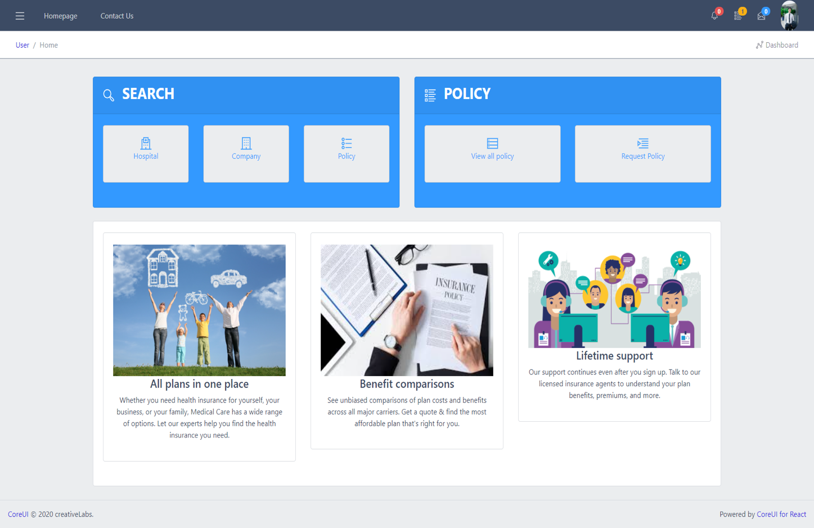

* At home page Guest can:
* Click Homepage to view Hompage page
* Click Contact Us to view Contact page
* Click  to view Profile and logout (User avatar)
* Click  to view Sliderbar

1. **Contact Page**

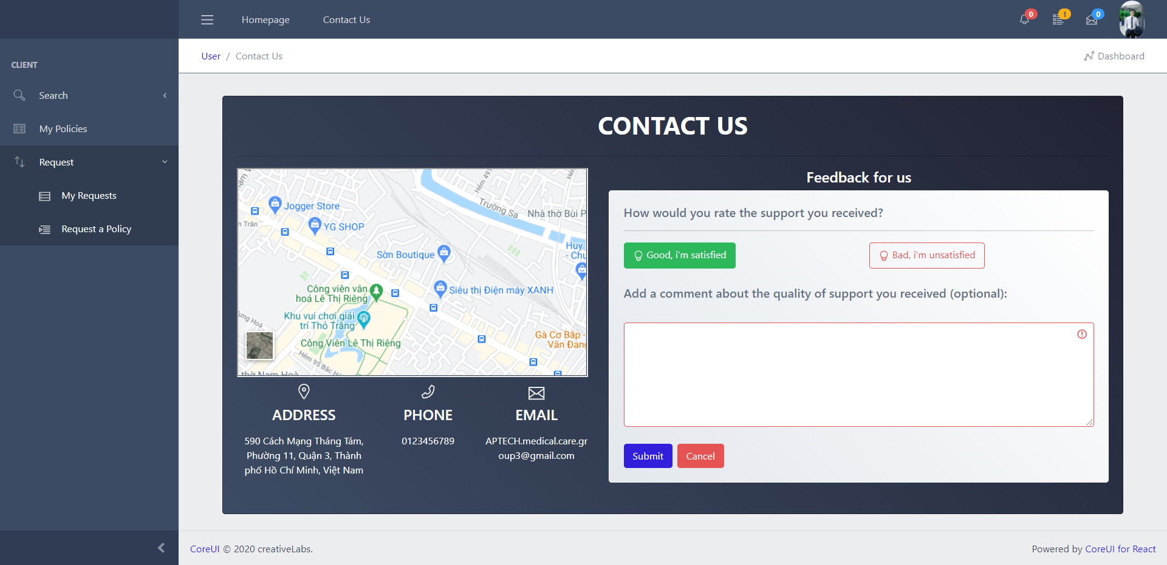

* At Contact page Guest can:
* Send feedback to Admin

1. **Search Page(in Sliderbar)**

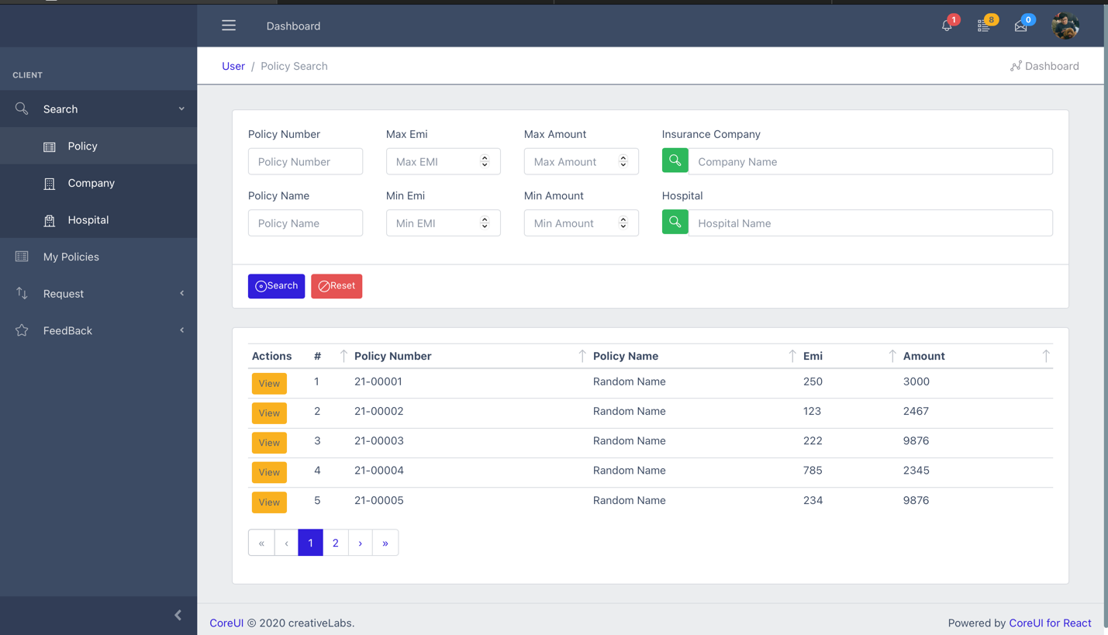

* At Search page Guest can:
* Search Policy , Company ,Hospital to see the details

1. **Feedback Page (in Sliderbar)**

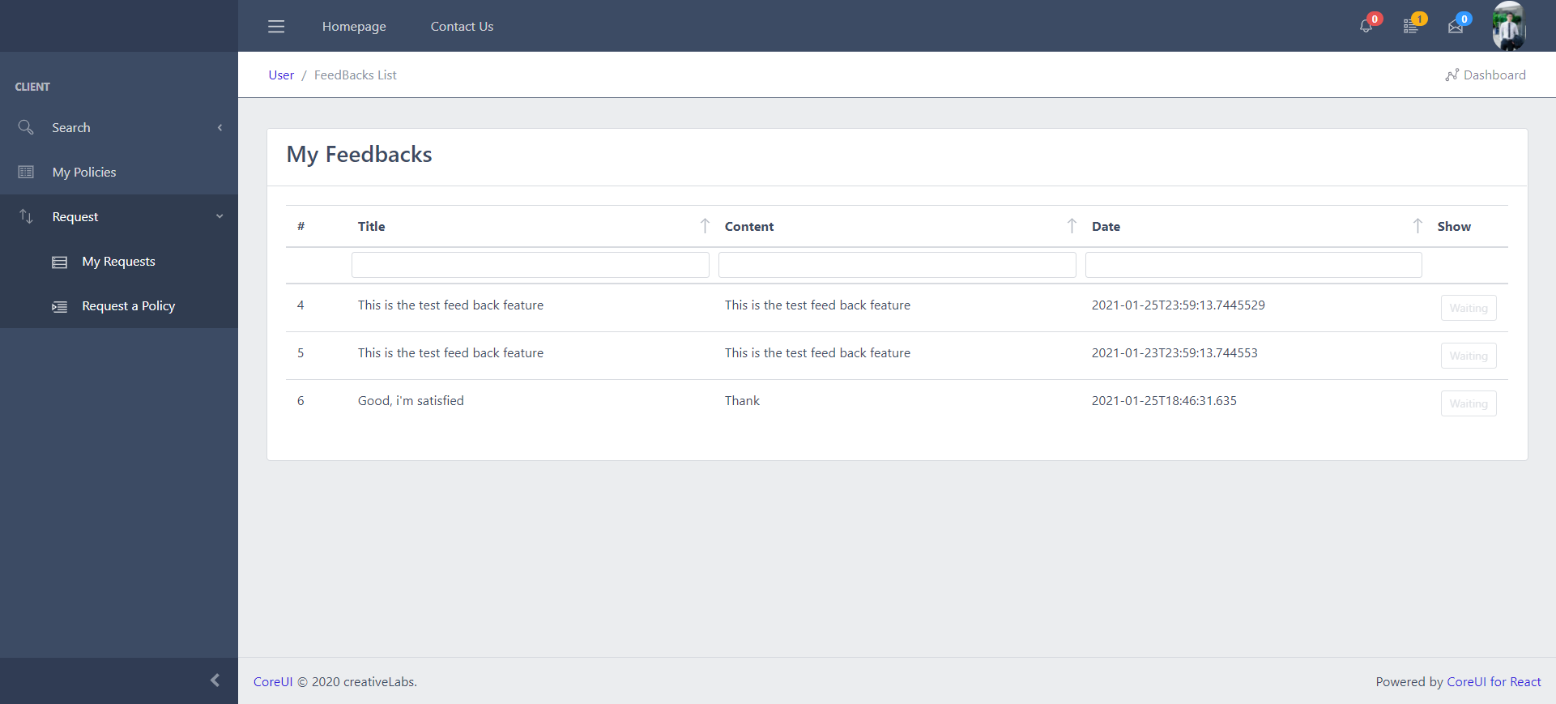

* At Feedback page Guest can:
* See the feedback employee have submitted
* Represents 2 states, waiting,feedback(if feedback you can click and see detail of feedback from admin)

1. **Request Page (in Sliderbar)**

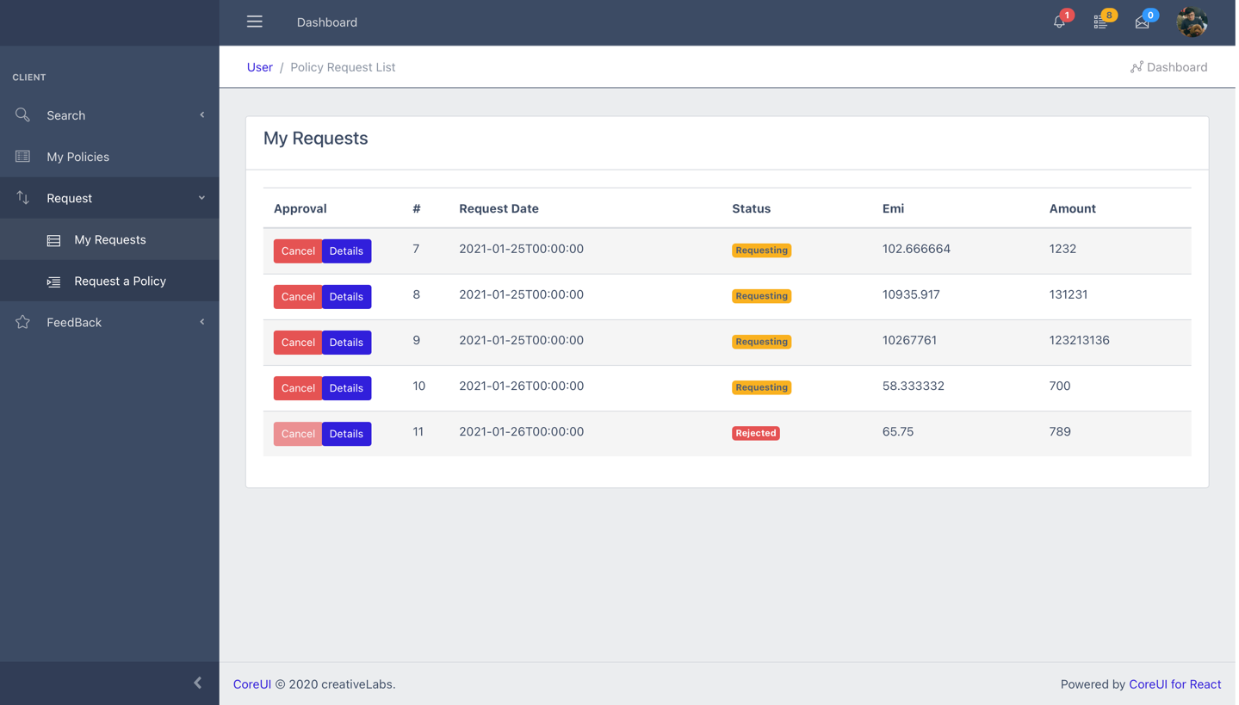

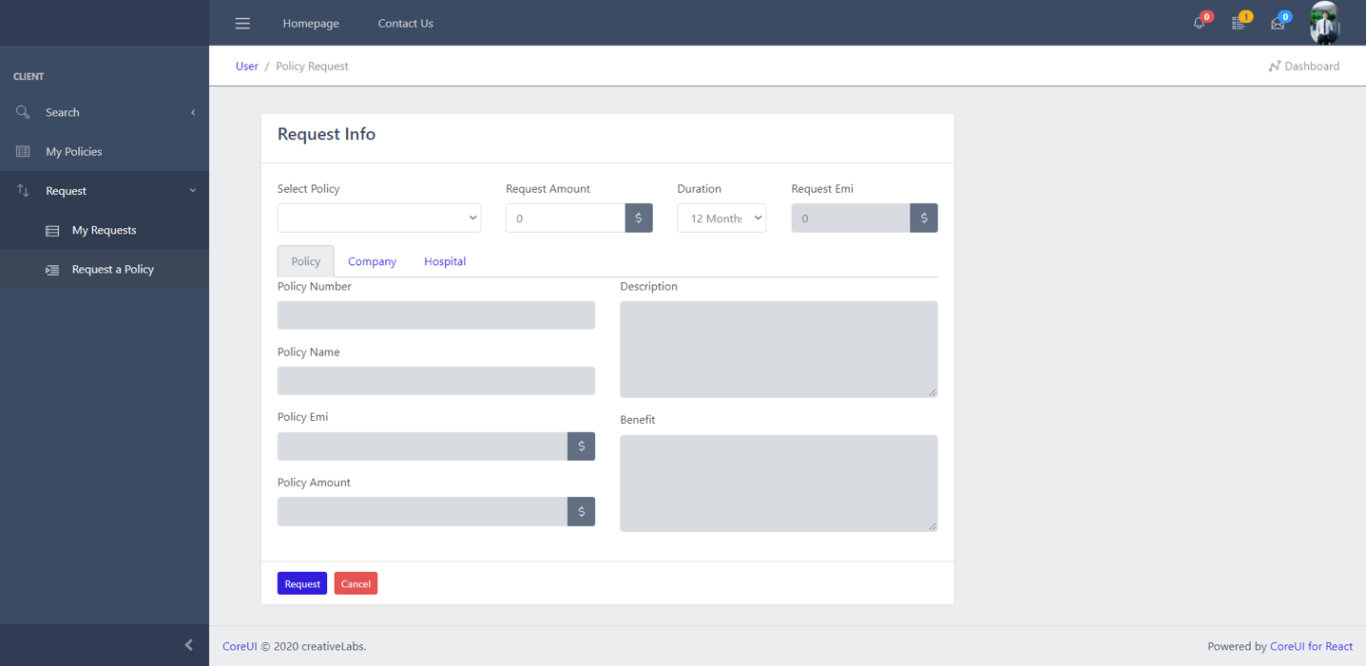

* At Request page Guest can:
* See all request
* If the request is not accepted, the employee can cancel
* Click detail to see detail of request
* Create the request to Admin

1. **My Policy Page(in Sliderbar)**

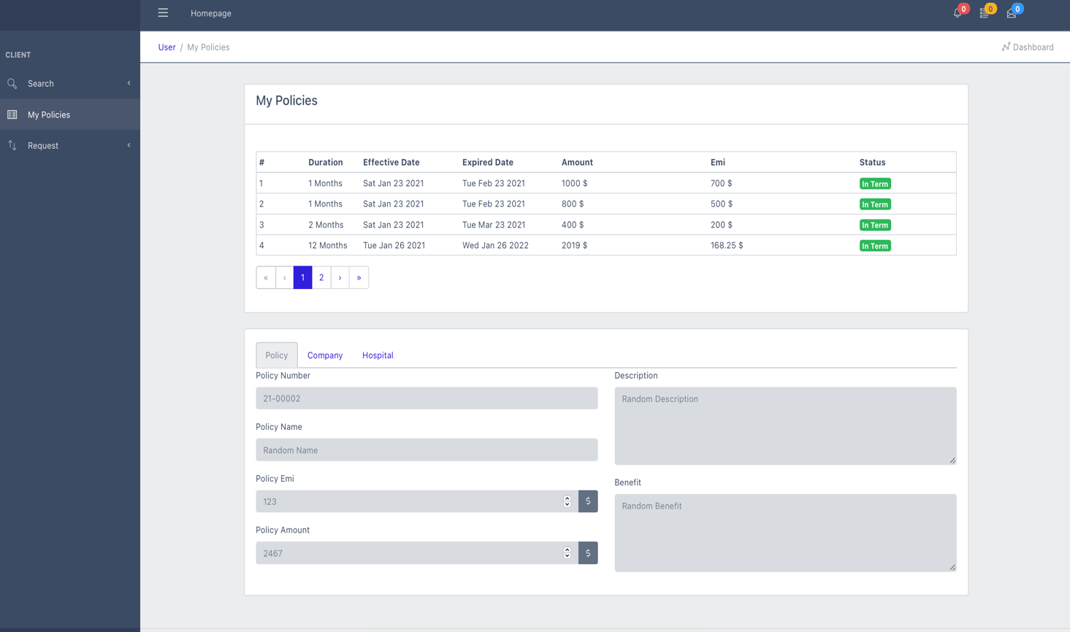

* At My Policy page Guest can:
* See your existing policies
* Click row to see details at belows

1. **Back-End (For Admin)**
2. **Login**

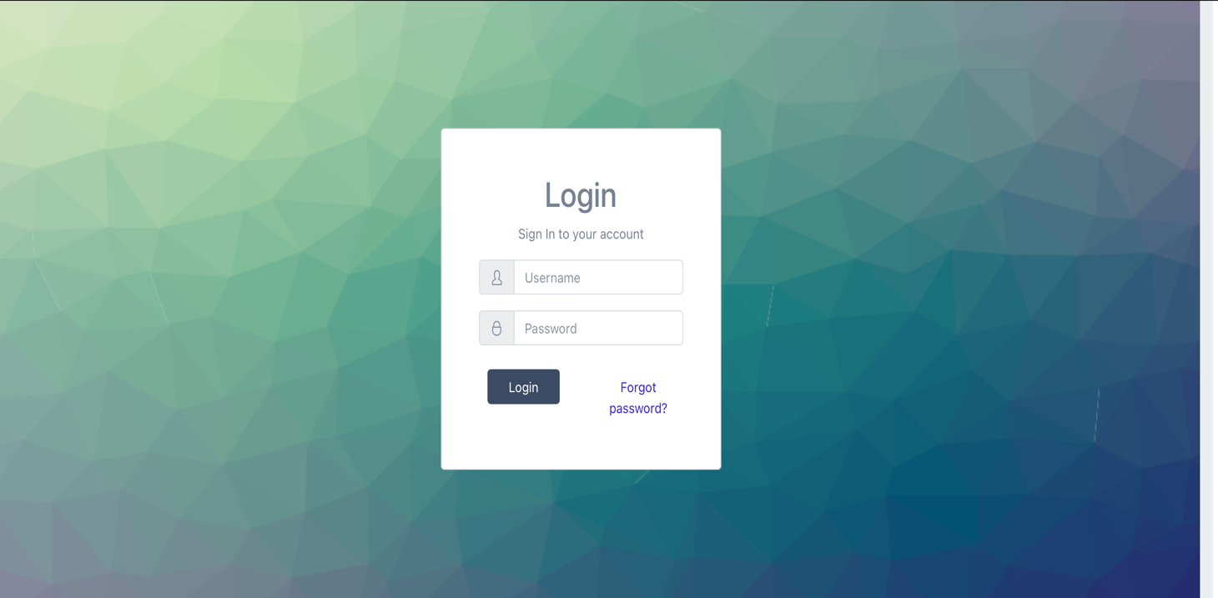

* Input ID:admin and Password:123
* To Login and go to Dashboard

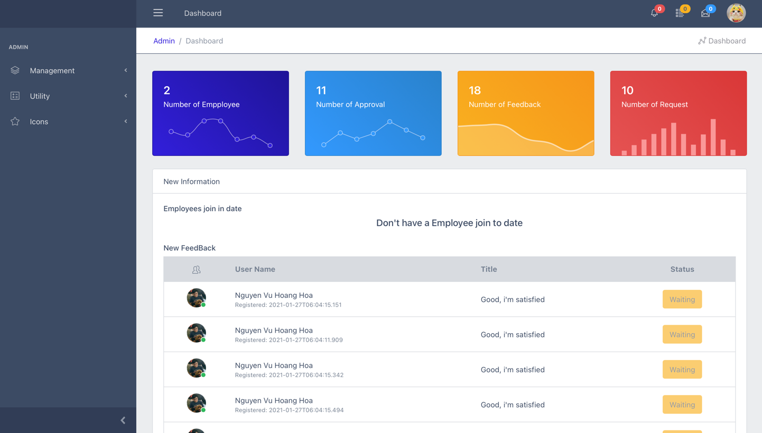

* At Dashboard page User can:
* See new information in date
* Click to row in table to see detail of new information
* Click avatar of user to see detail
* Click  to see new notification ,click  to see new mail , click  to see old notification
*  to see sliderbar

1. **Add Resource**
2. Add Company

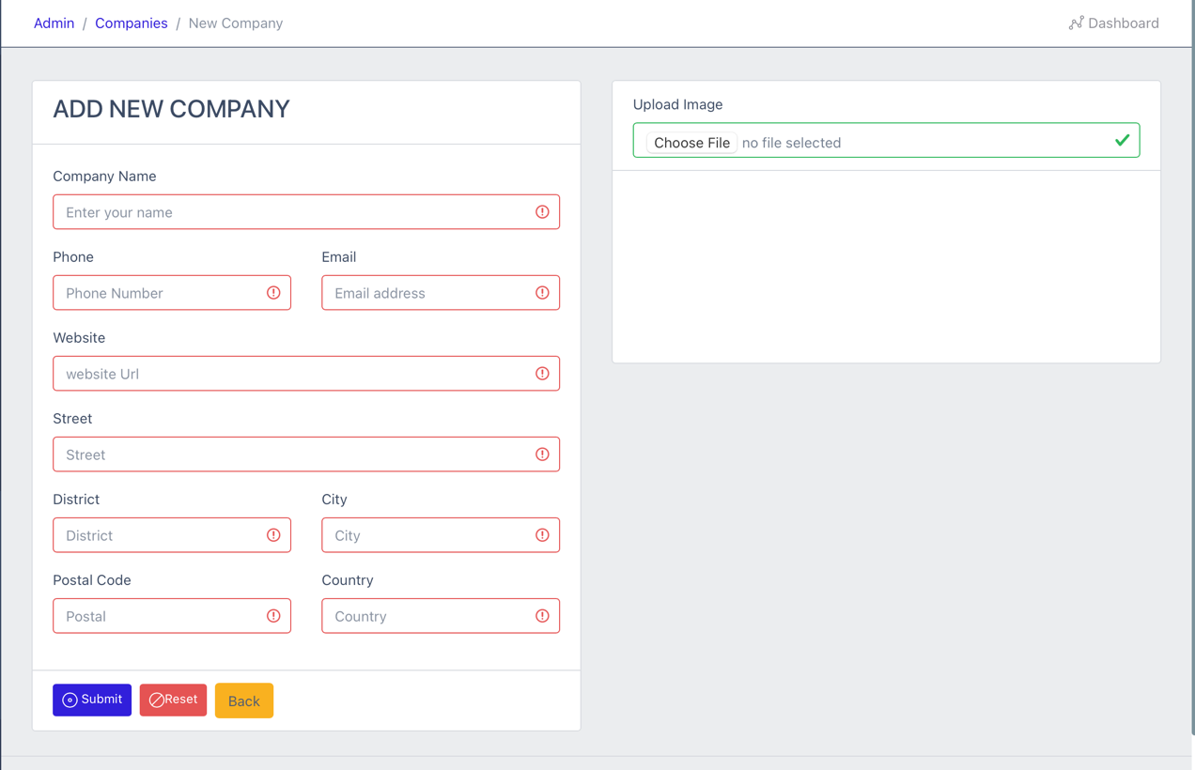

1. Add Policy

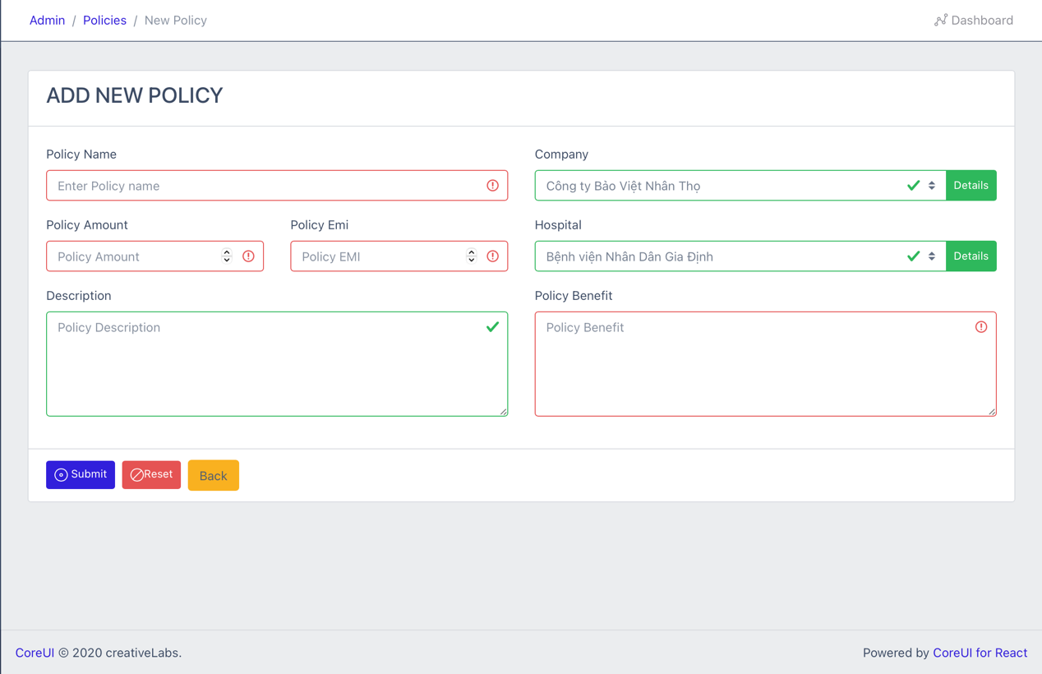

1. Add new Hospital

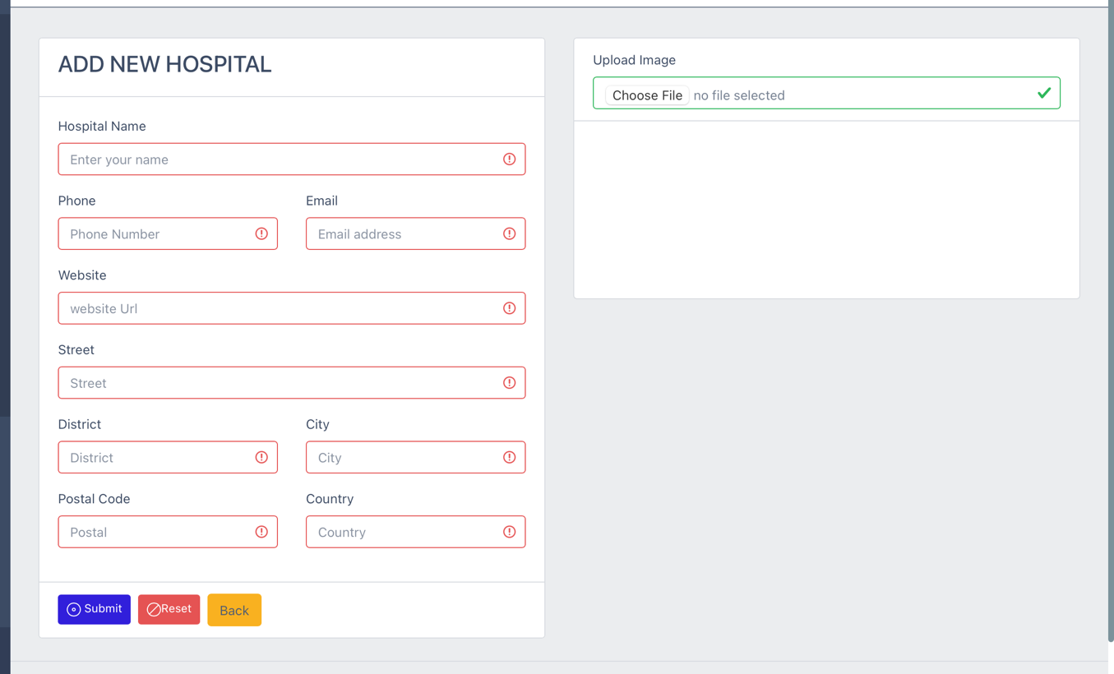

1. **Employee Support**
2. Employee Information

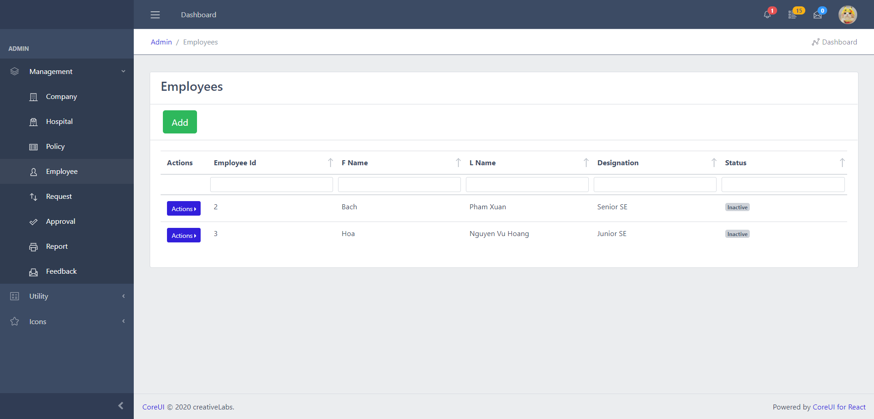

* At Employye page Guest can:
* See all employees in the system
* Click Add to add employee
* Click Action to see 3 options to choise:
  + Click Infor to see details of employee
  + Click Update to edit information of employee
  + Click Delete to remove employee
  + Click Print to print employee information .

1. Add New Employee

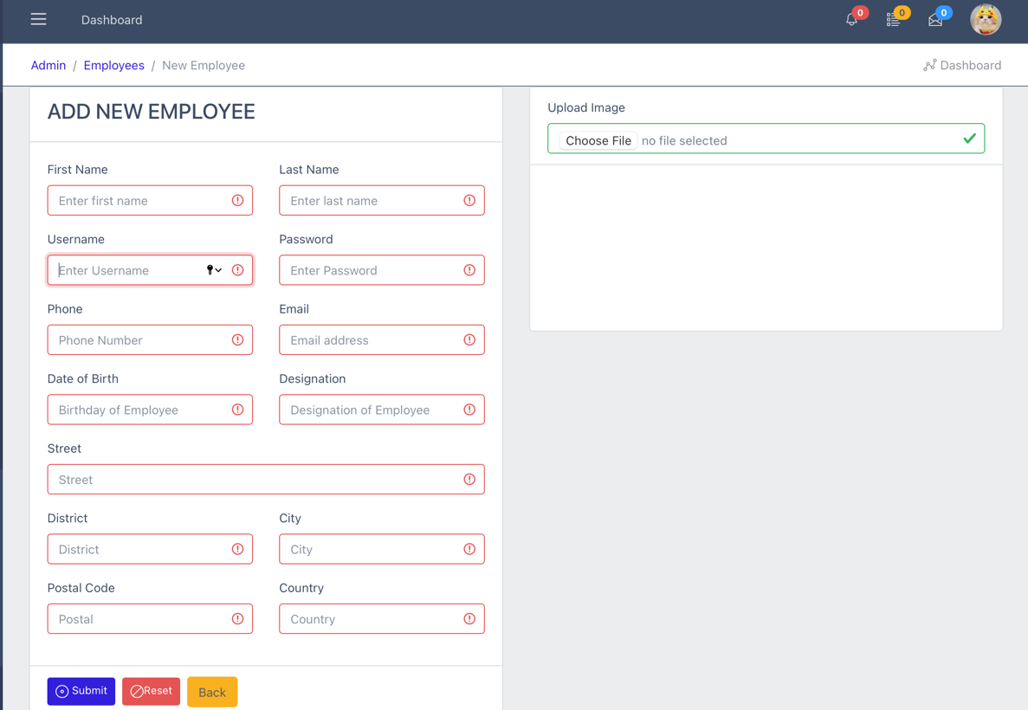

1. Edit Employee

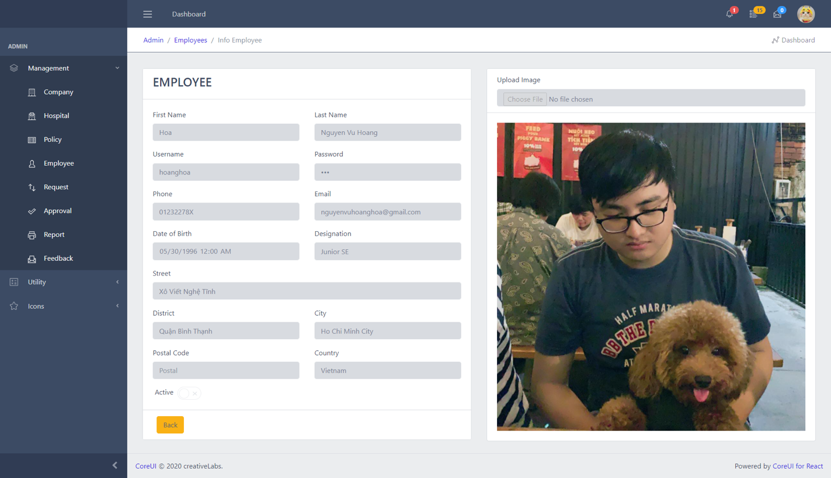

1. PrintEmployee

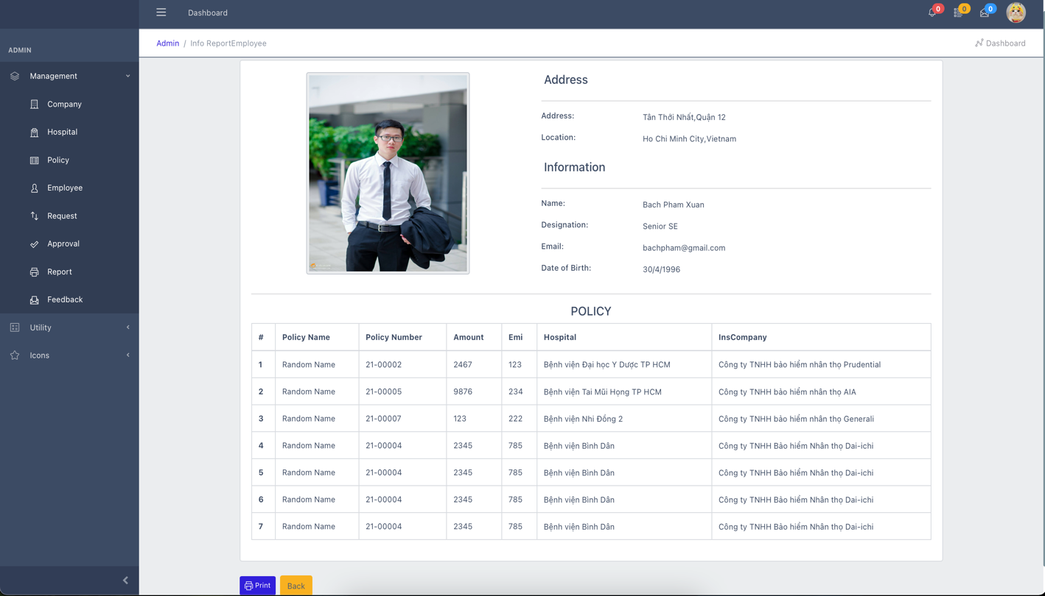

1. **View Request Status**

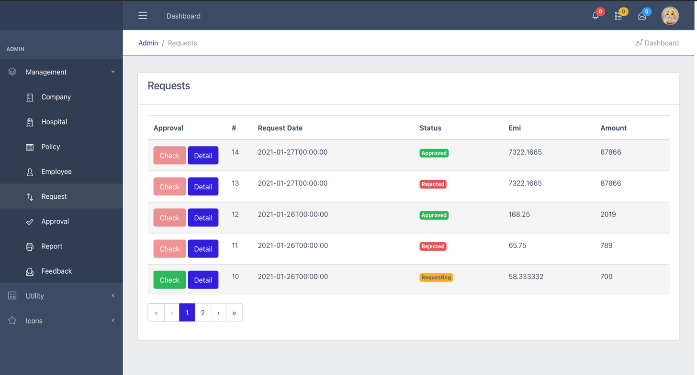

* At Request page User can:
* See all Request (status show the request is approval or rejected )
* Click Details to see request details
* Click Check to show and approval the request (Green button without confirmation and the button is red when confirmed)

1. **View Report Status**

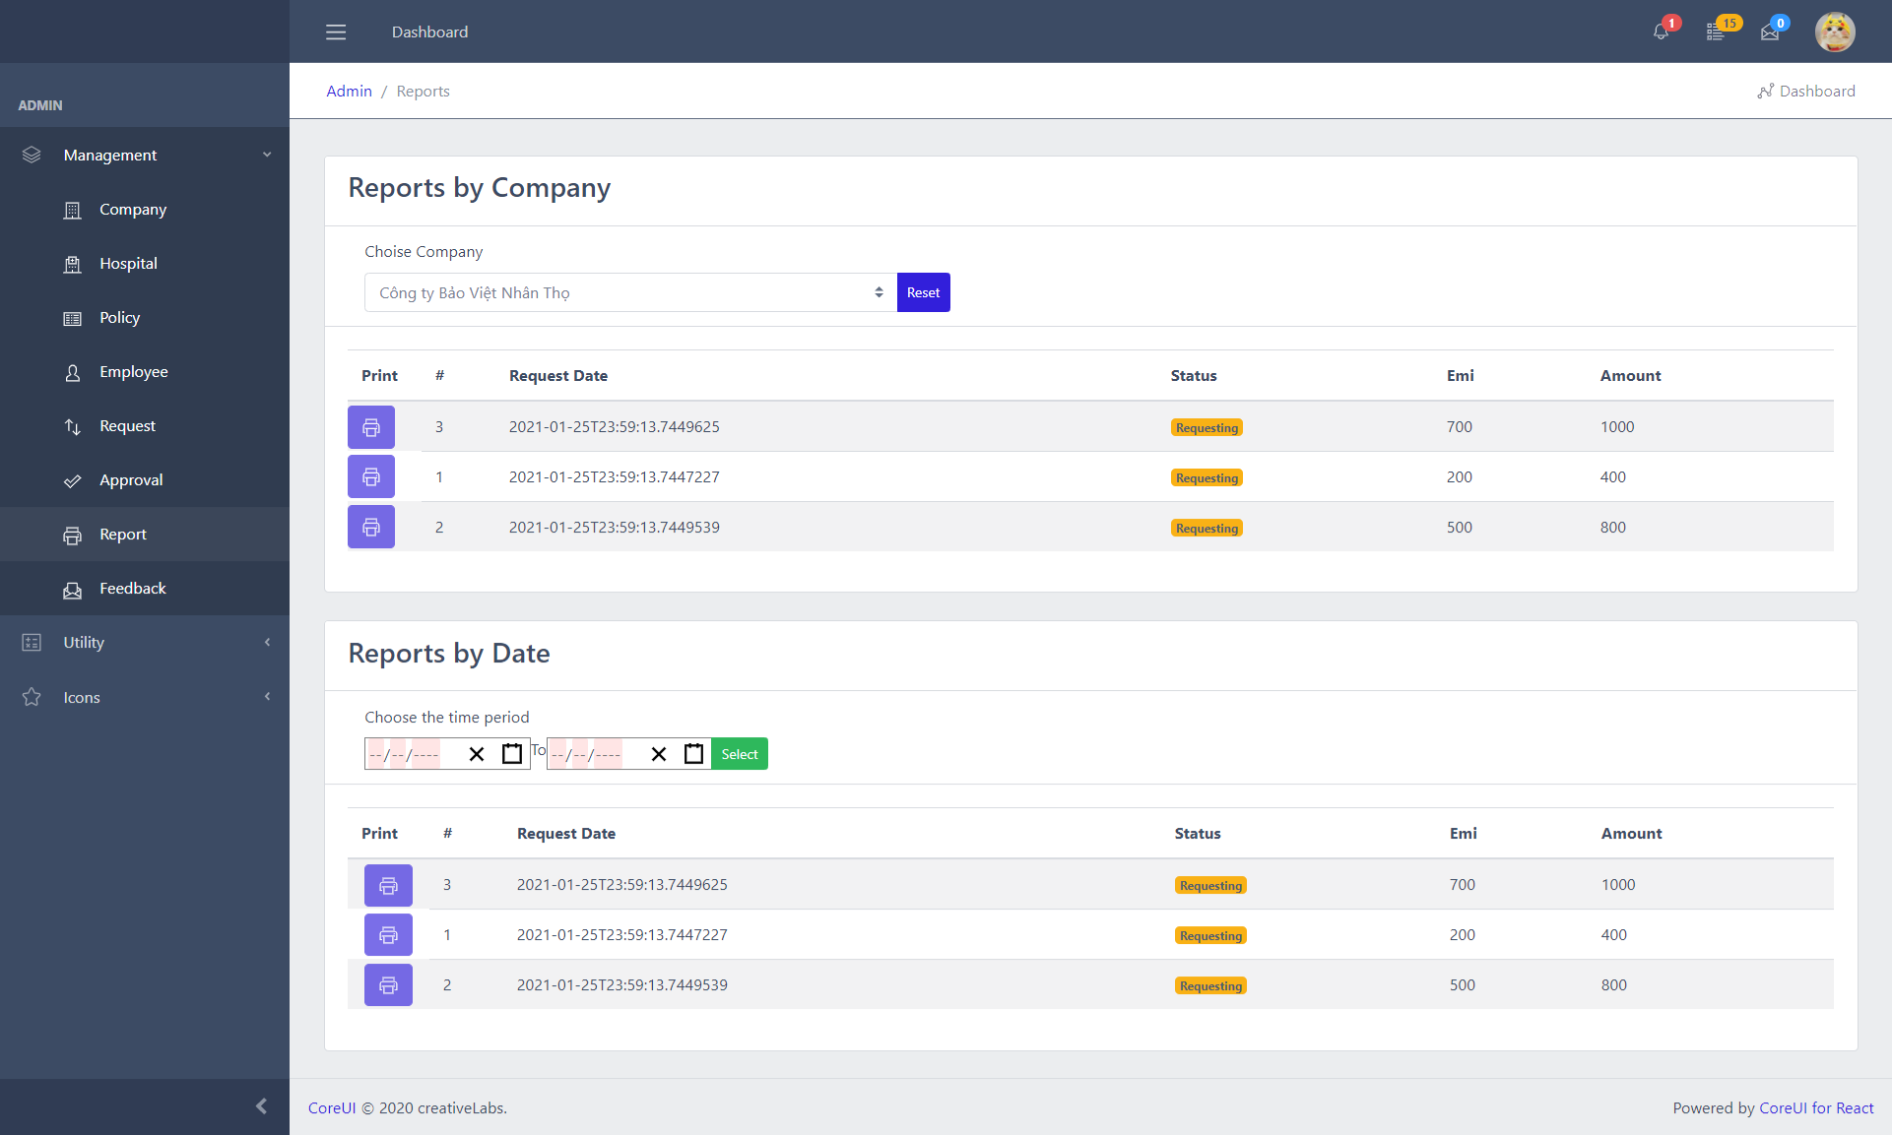

* At Report page Guest can:
* See all Approval request
* Admin can print when click the print button

1. **View Feedback Status**

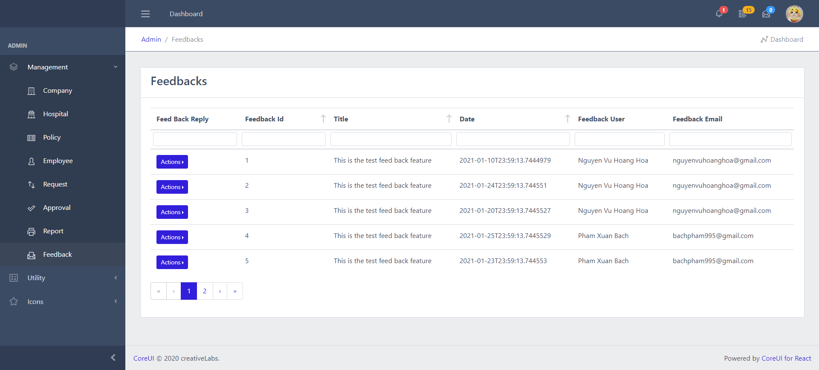

1. **View Approval Status**

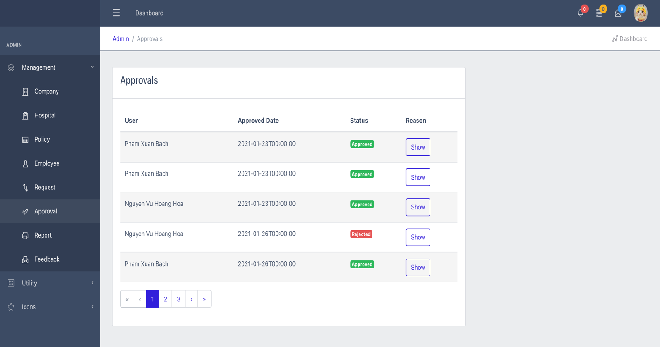

* At Aproval page Usre can:
* See all Approval request
* Hover show to see reponse

1. **Back-End (For Employee)**

**1.Login**



**. Username:admin**

**. Password: 123**

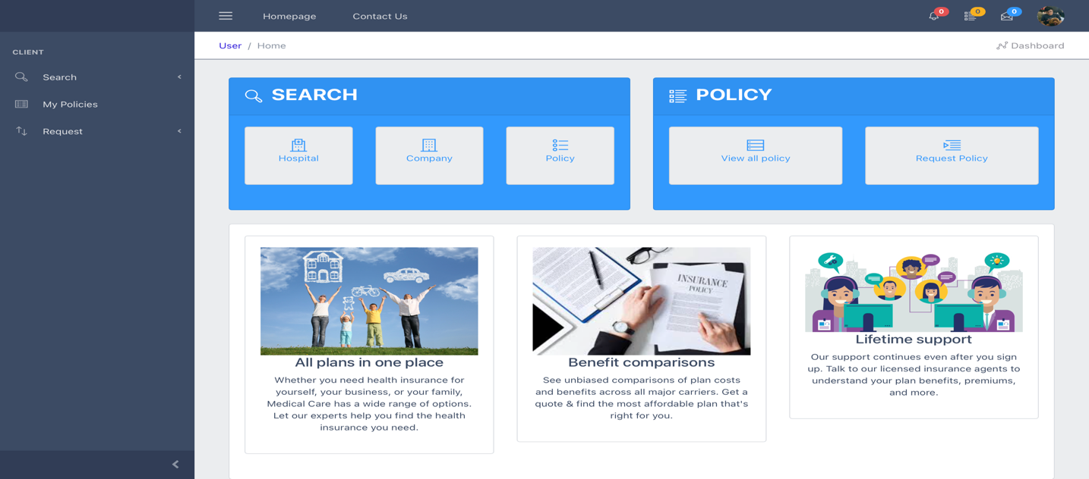

**2. Edit Profile**

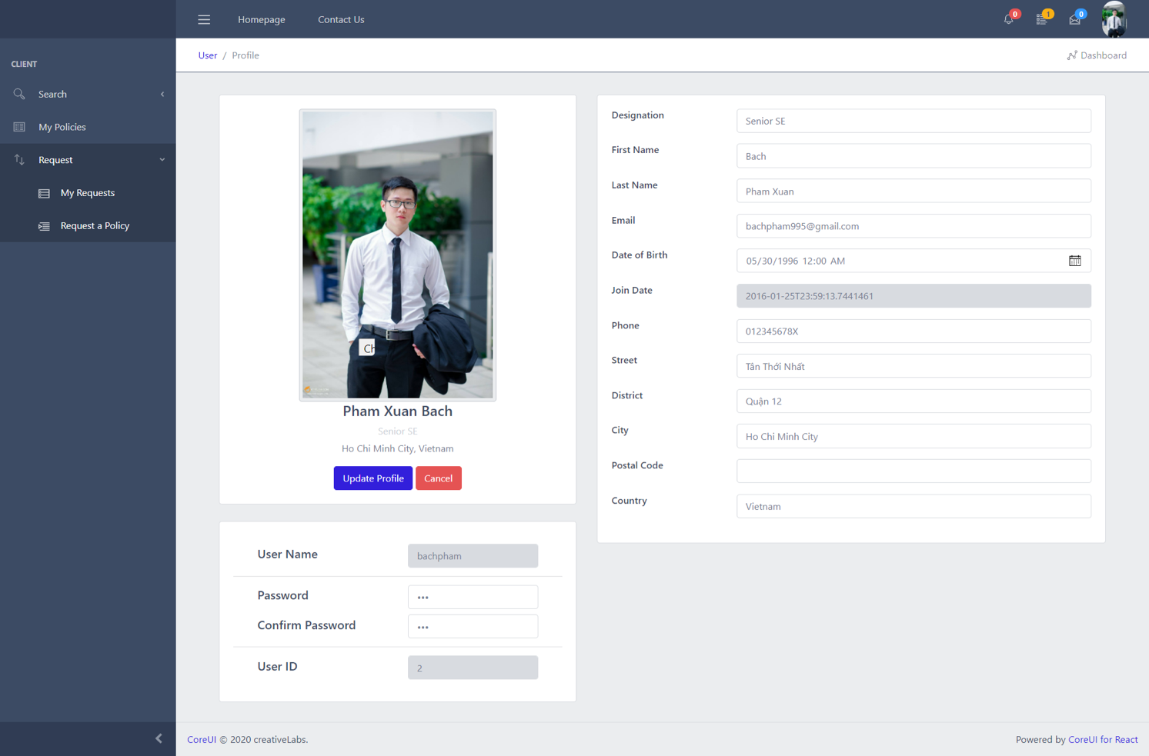

* At Edit Profile page Guest can:
* See the information
* Click Update to update information(If the user updates successfully, they will logout to login page )

1. **Setup System**

1. Server side.

- Open the folder ‘Backend’

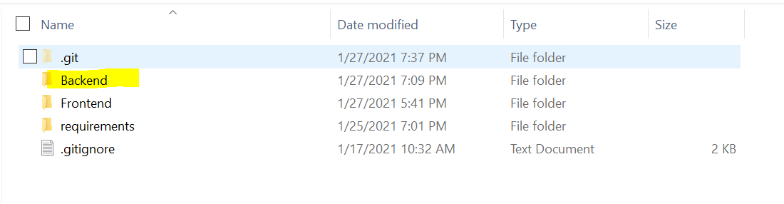

- Open file HealthInsuranceWebServer.sln



* Tool -> Nuget package manager -> Package manager console , then run the command below



* Run the command below



* Start server

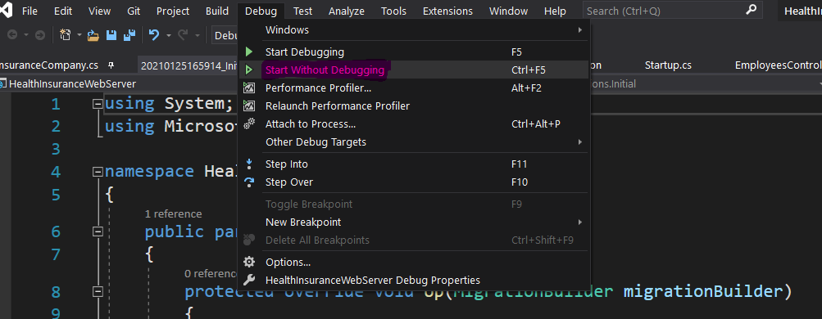

2. Client Side

- Open folder “Frontend” with Visual studio code



* Run -> New Terminal

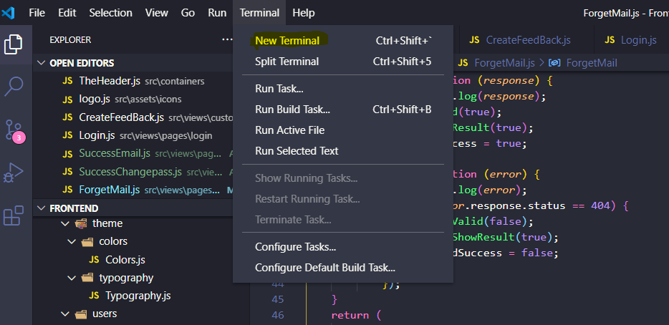

* Installs node module



* After installs node module success



* After start client

